Shoot The Lobster - New York City
540 W. 29th Street
New York, NY 10001
contact@shootthelobster.com
www.shootthelobster.com

FOR IMMEDIATE RELEASE

Shaun Flynn, David Ostrowski, Max Warsh
Organized by Nudashank
July 10 - July 27
Artists Reception: July 10, 6 - 8 pm

Shoot The Lobster – New York City is pleased to announce a collaboration with Nudashank, an independent, artist-run gallery in Baltimore, Maryland founded by Seth Adelsberger and Alex Ebstein. Opened in 2009, Nudashank focuses on showcasing and contextualizing local, national, and international emerging artists.

This exhibition brings together three artists who each approach their work with a distinct material sensibility that recombines easily recognized urban construction and textural elements in direct ways. These works exemplify a raw exploration of abstraction and materiality through photography, painting, and sculpture.

An Artists Reception will be held Tuesday, July 10, 6 – 8 pm.
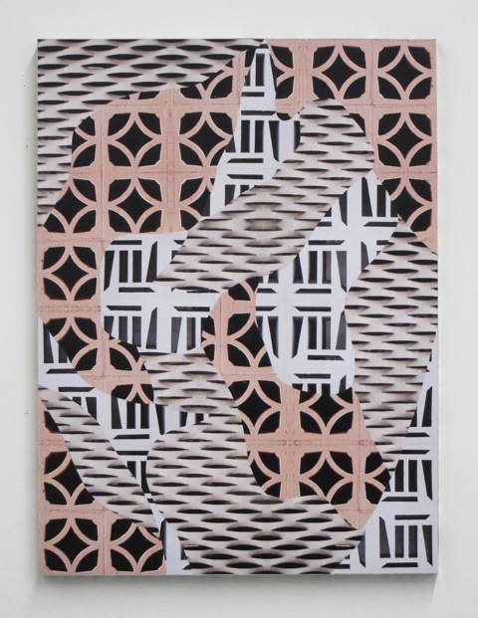
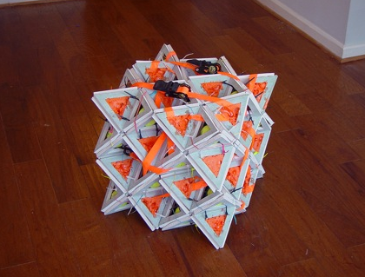
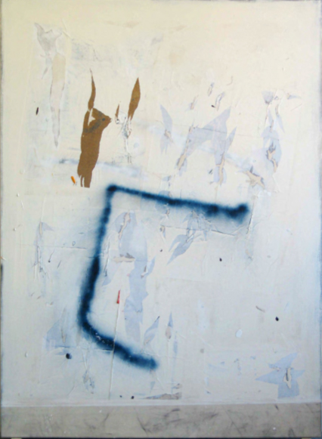
Left – Right:
David Ostrowski (Cologne)
Shaun Flynn (Baltimore)
Max Warsh (Brooklyn)

